**CLINIC PATIENT FILE**

**MEMBERS:**

**22201475 AQILAH ESSACK**

**22270056 MHLENGI MKHIZE**



**MANAGEMENT SYSTEM**

DIIBA1 - MILESTONE 2 PRESENTATION

**SmartCare Systems**

GROUP 11

**CONTRIBUTED**

**CONTRIBUTED**

**CONTRIBUTED**

**CONTRIBUTED**

**CONTRIBUTED**

**CONTRIBUTED**

**CONTRIBUTED**

**22467869 MPILWENHLE NDLELA**

**22341417 HLENGIWE NGEMA**

**22027713 LONDEKA NGUBANE**

**22422193 SMISO SIBIYA**

**22494044 ANDISWA SITHOLE**

# Problem Description

The Problem : Patient records at Glen Earle Clinic are manually filed on paper

Why it's an issue: The clinic is expanding, and the outdated approach isn't working.

Important Concerns

Record Loss: Incomplete patient records might result from files being missing or lost.



Long wait times are caused by staff members spending up to fifteen minutes looking for a file.

Security Risk: Due to easy access, paper files provide dubious confidentiality.

Files are only available at a specific location, which is inconvenient.

Patient danger: Without complete medical records, doctors run the danger of treating patients incorrectly.

## System Vision: The Solution

Key Capabilities:

Patient File Digitization: Convert paper files into electronic files stored in a central

***System Name :***

Digital Patient Record System

|  |
| --- |
| ***The Goal :***  Fulfil the business's demand for dependable, secure, and quick record keeping. |

database.

Secure Storage: Use encryption, passwords, and access restrictions to safeguard data.

Quick Search: Using the patient's name, ID, or visit date, you can quickly retrieve files.

Audit Trails: To increase accountability, keep track of who has used or updated records.

## Business Benefits

 Improved Patient Care: With comprehensive and precise information at their disposal, doctors will be able to make better treatment choices.

Faster Service: Patients wait less when records are retrieved promptly.

Enhanced Security: Password-protected records are only accessible by approved personnel.

Reduced Risk: Data backups shield documents from being lost due to accidents, theft, and fires.

Staff Efficiency: By spending less time searching for files, staff members can spend more time providing patient care.

## Stakeholders & Analysis Activities

The main stakeholders are regular users:

Patients: Require safe, conveniently accessible, and accurate records.



Every day, doctors and nurses access and update records.

Administrative Staff: Make appointments, keep track of records, and register new patients.

|  |
| --- |
| Key Analysis Activities:  Requirements gathering: To find information (such as prescriptions and visit details), surveys, interviews, and observations were used.  Process modelling: To identify delays and risks, the current paperbased workflow was mapped.  Core entities and their relationships (Patient, File, Doctor, Appointment) were identified through data analysis. |

Li n



Facilitate the generation of patient files and registration.

Permit employees to update records with new

appointments, medications, or therapies.

Make it possible to search patient files quickly and

securely.

Assist with appointment scheduling and management.

**Non-Functional Requirements**

**(**

**How Well the System Performs**

**):**

Performance: It takes two seconds to retrieve patient

records.

Security: Needs audit trails, encryption, and access control.

Compliance: South African POPIA laws must be followed.

Usability: Employees with little computer skills should be

able to use the interface with ease.

St

akeholders & Analysis Activit

ies

**Functional Requirements (What the System MUST do):**

ACTIVITY DIAGRAM: Important Actions and Objective:

Workflow The objective is to visualise patient

PATIENT INTERSCTION involvement and expedite appointment

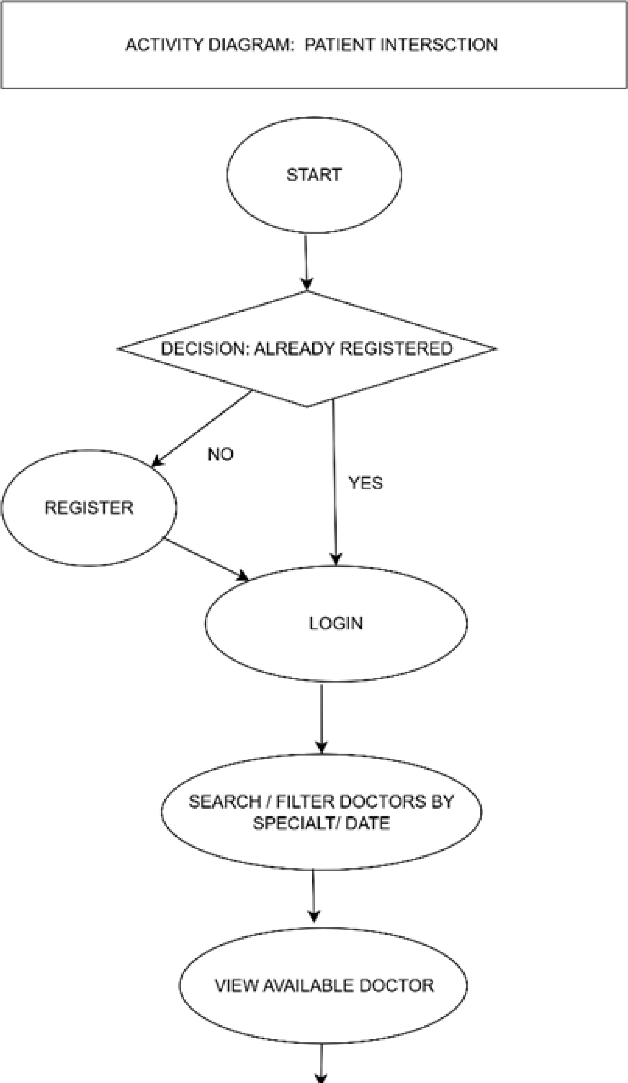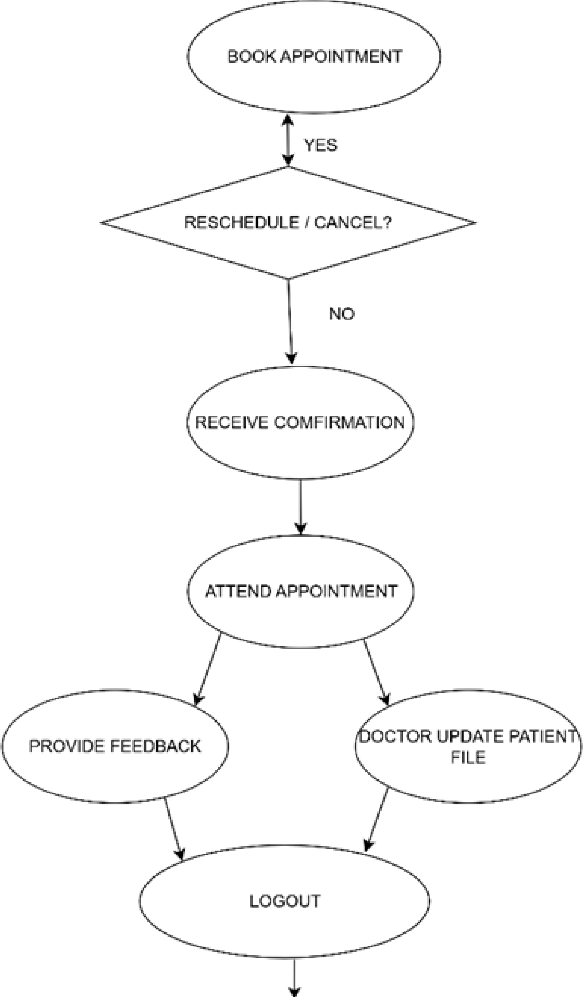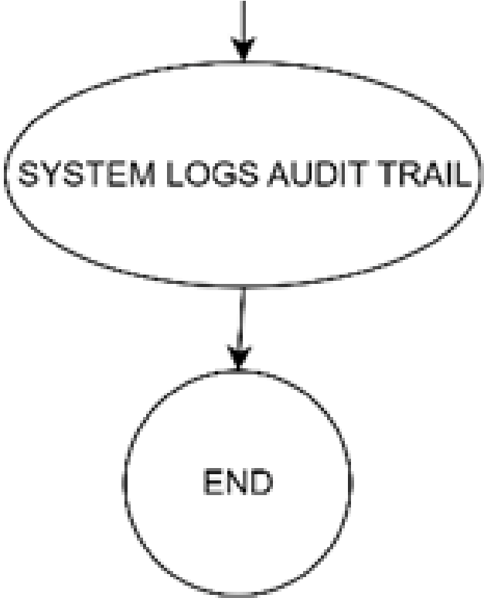

booking.

Start: The patient logs in or registers first.

Booking: Patients can make an appointment by searching for and filtering doctors based on specialisation or date.

Important Decisions: After examining the available providers, patients can choose to cancel or reschedule their appointments.

Post-Visit: The physician may provide feedback or update the patient file following the visit.

End Process: The system logs an audit trail after the interaction is finished with logout.

|  |
| --- |
| **Core Entities & Relationships**  Core Classes: Patient, Doctor, Appointment, Record, and Department.  Patient to Appointment: Patients can schedule multiple visits.  Appointment to Record: Medical Records (with diagnoses and treatments) are created during appointments.  Doctor to Department: Physicians are grouped into Departments according to their areas of expertise. |

|  |
| --- |
| **System Value**  Makes it easier to efficiently organise data for clinical documentation and patient visit management.  Ensures accurate recording of medical encounters and administrative processes.  Promotes better patient care and more effective operations. |

## Domain Class Diagram

## Use Case Diagram

**Primary Goal:**

To clearly define the system's boundary and show how it handles both administrative and patient care duties effectively.

Key Actors (Participants):

The system is designed to support different user roles:

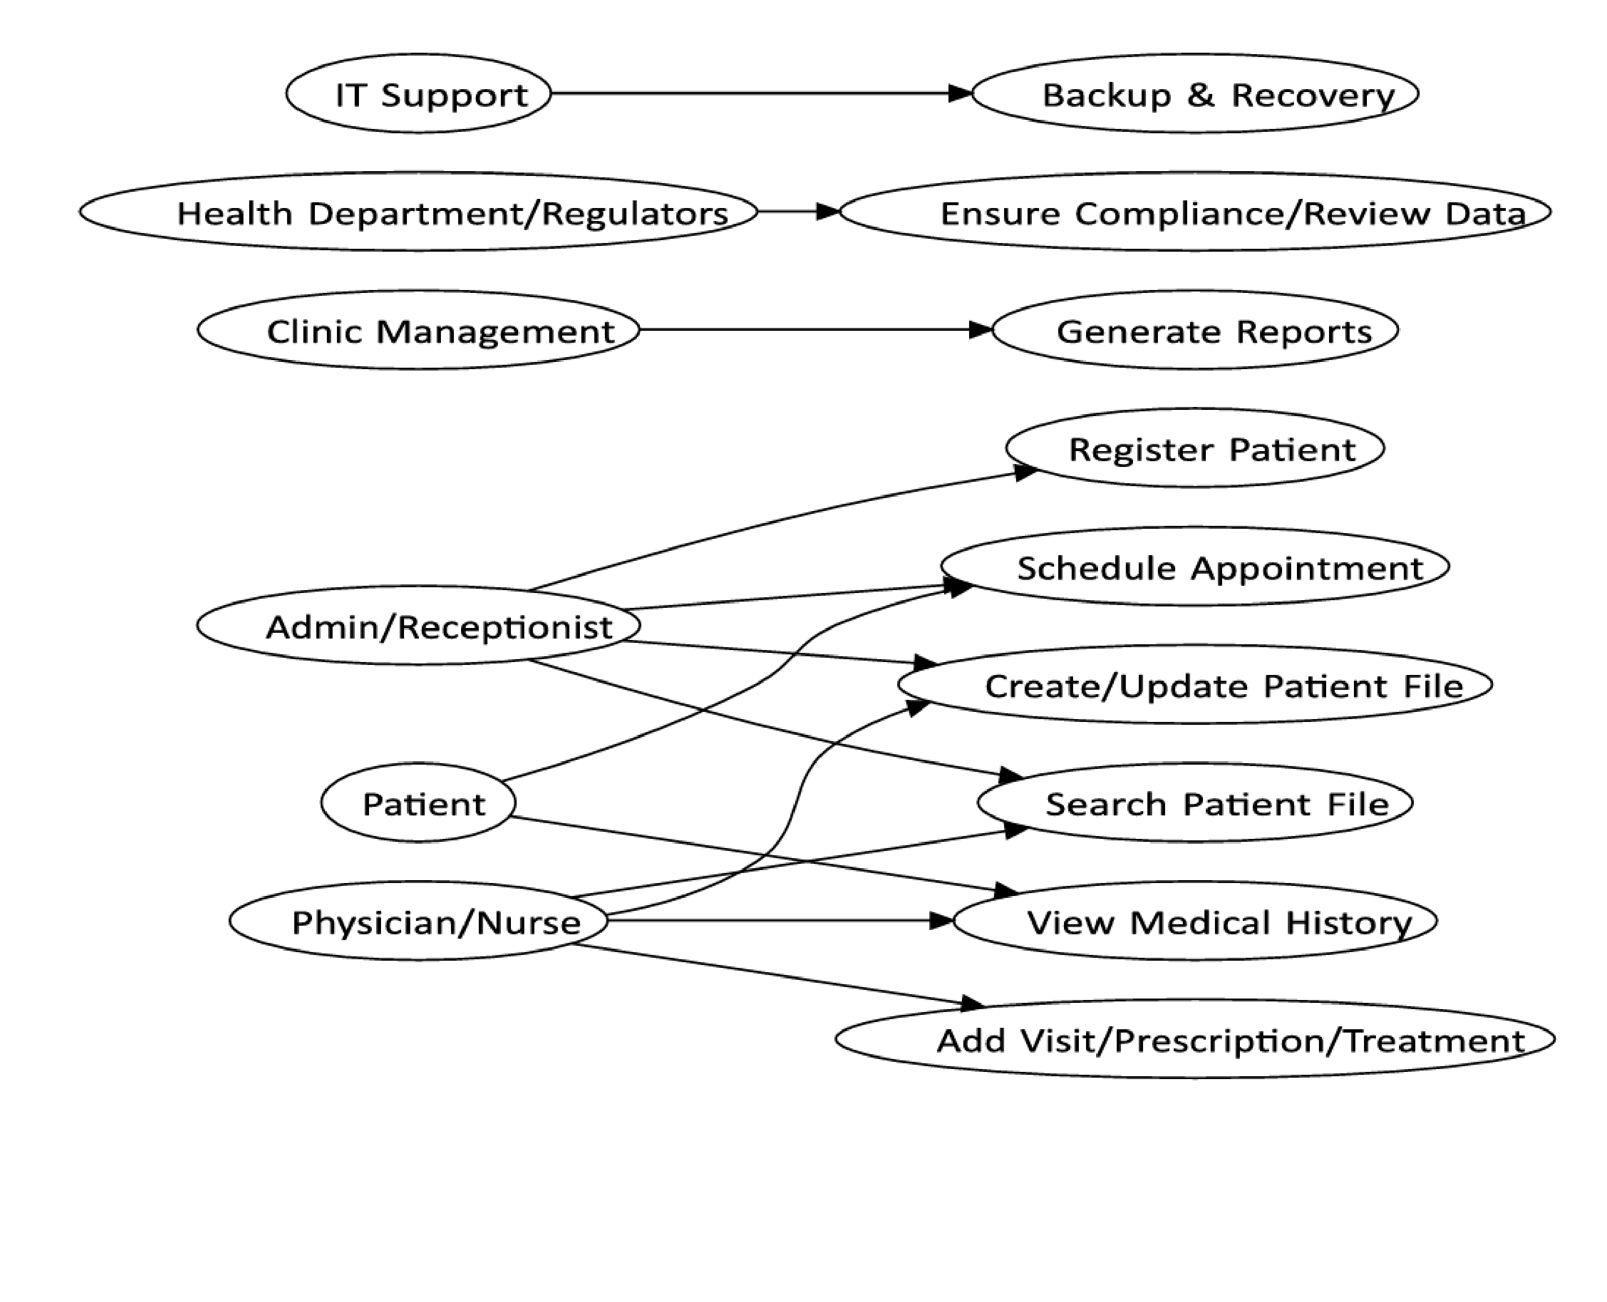Administrative Assistant/Receptionist

Physician/Nurse

Patient

Clinic Management

IT Support

Health Department/Regulators

**FOCUS ON INTERACTION**

Each actor's unique interactions and tasks—such as scheduling, file updates, and report generation are highlighted in the diagram.

It guarantees that every important stakeholder is included in the design process.

**SmartCare Systems**

# CONCLUSION & PROJECT DELIVERABLES

**The System's Impact:**

The Digital Patient Record System promotes effective, patient-focused healthcare delivery by ensuring better patient care, faster service, and improved security

**Milestone 2 Deliverables Complete:**

We have successfully defined the System Vision, Stakeholders, User Requirements, Activity Diagram, Domain Class Diagram, and Use Case Diagram.

# **Thank You**